1. **Agenda**:
   1. Changes to be made into Docker Compose file to integrate Eureka Server Image into it.
2. As we know all Docker Compose files (one for each environment) are maintained under accounts ms.  
   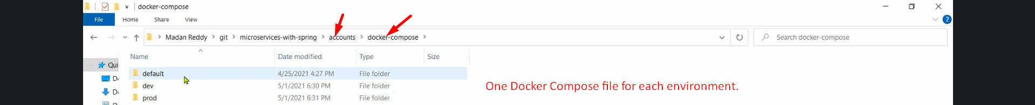
3. Let’s open Docker Compose File for default environment.  
   Graphical user interface, text, application

   Description automatically generated  
   Graphical user interface, text, application, Word

   Description automatically generated

All the above changes need to be made for Docker Compose files for other environments such as DEV, PROD.